Career & Employment Service

Table of Contents
These questions and clear steps are designed to bring you closer to your dream job and to develop your self-awareness and employability skills. The best way to use this workbook is to keep adding to it throughout the Professional Development Program, and beyond!
Professional Development Program
Workbook
1. My VIPS (Values, Interests, Personality, Skills)
2. Employability skills
3. Developing Experience
4. Informational Interview
5. Exploring your Options
6. My Career Goal
7. Job Search - Ways to look for work?
8. Job Analysis
9. My resume/CV
10. My referees
11. Cover letters
12. Be the recruiter exercise
13. Interview skills
14. Interview Exercise
15. Assessment Centres
16. Linkedin
17. Professional Branding
18. My Online Presence
19. Networking – My Elevator Pitch
20. Compass exercise questions
21. My Career Action Plan
22. How will I stand out from the crowd?

Workshop 2

- Job Search - Ways to look for work (Slide 23)
Ways I could look for work include:

- Job Analysis HOMEWORK (Slide 36)
Now, take some time to create a skills/examples inventory. Pick one skill (e.g. Analytical Mind)
mentioned in the previous job ad and brainstorm with dot points to start with, then select the best examples and flesh them out with detail. This will form basis for your marketing plan!
Complete the same exercise when applying for any job.
(Make a note of all relevant skills required for the job, then think of examples from your current jobs, previous internships or unitiversity or even extracurricular activities that demonstrate how you have developed that particular skill).
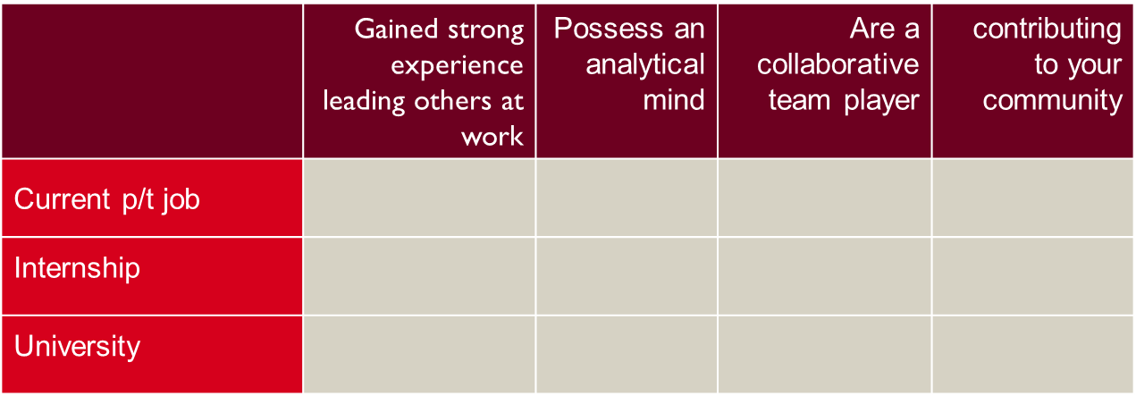
e.g.: Contributing to your local community: I was member of a Life Surfing Club last year. One particularly busy day we had to rescue 3 people at the same time, as they were all dragged into a rip. Only through orchestrated team effort were we able to save their lives. I spotted them and alerted my team members through our advanced communication system, one drove the jet ski and one pulled them to safety….

Job Analysis HOMEWORK (Slide 36)
In a next step, pick 2 job ads (e.g. through Seek.com.au or CareerHub) within your field of study and analyse the ads by filtering out the key requirements and skills needed for these jobs. Write down the requirements and think about what you could do now, to develop those particular skills for the future.

Key skills and requirements found in 2 job ads.

What could I do now to develop those skills (e.g. complete a LinkedIn Learning course)?

- My Resume / CV HOMEWORK (Slide 62)
Given what you’ve learnt in Workshop 2, spend some time reviewing your resume and perhaps attend a Resume Rescue Workshop (book through CareerHub - Events).
In particular, take some time to re-write your profile section. Include, who you are, what you want (internship in Marketing?), and what you can offer a potential employer (skills/strengths!).
My Profile

- My Referees HOMEWORK (Slide 62)

It’s important to think about who you could ask to be your referees. Brainstorm potential referees below. Referees should not be your friends or family members - ideally, they should be from your professional network of contacts (ideally previous managers, supervisors or work colleagues).

Name | Organization | Relationship to me | Contact details

Critically evaluate the list you’ve brainstormed and select 3-4 people who could be your referees. Make sure you have people who can comment on your different strengths/experiences. For example, one of the referees could be your supervisor or employer, while another one may be your university lecturer, etc.

- Cover Letters HOMEWORK (Slide 62)
Writing good cover letters takes practice. Refer to the 2 jobs you have previously selected and practice writing cover letters for them. Make sure to tailor each cover letter to each individual job. You might want to save them in separate Word documents for future reference. Refer to the cover letter handout for further instructions.

- Be the recruiter notes HOMEWORK (Slide 63)
Who did you select for the Marketing Assistant role at Pro Publishing, and why?

Were there any candidates you were undecided about? Why?

Why did you not choose the other 3 candidates? What put you off? What could be improved in their applications?

Notes

- Resume Check Exercise – (Slide 54)
Proofread and check the grammar, layout and content of the following resume – how many errors can you find? How else could the resume be improved?

RESUME
Jon Lind
Contact phone number: +91 4040 635 9041
Email address: coolcat00@gmail.com
Postal address: 7/48, Stanton road, NSW 2113
LinkedIn: linkedin.com/in/jon-lind-43800aa7
Career Objective
A friendly and responsible individual who can play a key role in the smooth running in a premise including all area and moreover can work in accounting support where focused on providing a consistently high standard of work and can work evenly with team members as well as communicate with clients. I am looking for a job which can provide me with new skills and mentor me for success.
Skills
•Data Entry
•Emotional Intelligence
•Teamwork
•Time Management
•Communication Skills
•Critical Thinking & High Level of Accuracy
•Attention to Detail
•Advance knowledge of MS Word, Ms Excel, Quick Books and MYOB

Academic Qualification

2019- 2022 B Accounting, Macquaire University
WAM 65
Key subjects
- ACCG224 Financial Accounting and Reporting
- ACCG350 Financial Statement Analysis
- ACCG330 Strategic Management Accounting
- ACCG308 Corporate Accounting and Business Advisory

2017-2019 Government Boys Senior Secondary School, Yamuna Vihar

2015-2017 Pt Yadram Secondary Public School, Chandni Chowk

Employment Experience
Feb-March 2019
Waiter, High Noon Café, Broadmeadow
- Assist customers with orders
- Clean and set up tables

March-April 2019
Relief manager, High Noon Cafe
- Manage café day to day operations
- Balance till
- Organise staffs
- Lock up at night
July 2019- current
Bookkeeping assistant, Brookside Accounting
- Accounts payable and accounts receivable
- Helped to prepare BAS statements
- Spoke to clients
- Data entry
Achievement:
Received good feedbacks from manager
Volunteer activities
Lifeline July 2020
Availability
Mondays and Thursdays 10am-2pm

References Available on request

I hereby declare that all the information contained in this resume is in accordance with facts or truths to my knowledge. I take full responsibility for the correctness of the said information.
Kind regards,
Sumar Lind

