Career & Employment Service

Table of Contents
These exercises and clear steps are designed to bring you closer to your dream job and to develop your self-awareness and employability skills. The best way to use this workbook is to keep adding to it throughout the Professional Development Program, and beyond!
Professional Development Program
Workbook
1. My VIPS (Values, Interests, Personality, Skills)
2. Employability skills
3. Developing Experience
4. Informational Interview
5. Exploring your Options
6. My Career Goal
7. Job Search - Ways to look for work?
8. Job Analysis
9. My resume/CV
10. My referees
11. Cover letters
12. Be the recruiter exercise
13. Interview skills
14. Interview Exercise
15. Assessment Centres
16. Linkedin
17. Professional Branding
18. My Online Presence
19. Networking – My Elevator Pitch
20. Compass exercise questions
21. My Career Action Plan
22. How will I stand out from the crowd?

Workshop 1

- My VIPS (Values, Interests, Personality and Skills)

Values – slide 29
My values are:
Note: A values tests can be found here: https://www.123test.com/work-values-test/

Interests – slide 30
My interests are:
Take this Job Outlook Quiz at home: https://joboutlook.gov.au/careerquiz.

My Personality Insight Test https://mquniversity.careercentre.me/resources/careerassessments/

Personality – slide 32-33

Skills – slide 34
My skills/strengths according to the Frank Team skills test are:

WHO are you? – Slide 35
What do your VIPS say about you? Who are you?

2. Employability Skills (Slide 42)

Which 5 employability/transferable skills would you still like to develop while at Uni? Can you come up with some ideas on how to build these skills?
5 skills I would like to develop this year in order of importance to me:

Homework: How could I develop those skills (action plan)?

3. Developing Experience – Slide 44

Team Exercise: Ideas on how you could develop your experience
Ideas on how you could develop your experience:

- Exploring your options - Slide 49
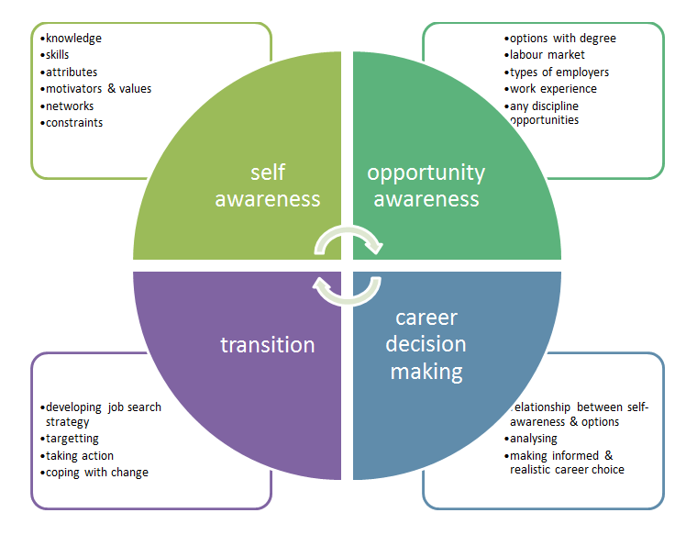

Homework: Now that we have looked at your VIPS (self-awareness piece), we want you to reflect on the next steps of Career Planning, namely the options with your degree (Opportunity Awareness).
Firstly, research some of the following websites, then make a note of possible career outcomes with your degree(s). Also make a note of the outlook for these careers and industries (earning potential, job outlook, etc.).

https://www.prospects.ac.uk/careers-advice/what-can-i-do-with-my-degree
http://joboutlook.gov.au/
https://www.victoria.ac.nz/st_services/careers/resources/career_publications/index.aspx

The options of interest to me are:

OR book an appointment through CareerHub if you are unsure what you could do with your degree/ options with your degree.

5. Homework: Informational Interview – Slide 54
- Seek out 1 employer in your chosen field and make contact, e.g. via LinkedIn Alumni
- Interview the employer – you can take notes, film, and/or make an audio recording, and ask:
  - “What skills are you looking for when hiring new employees?”
  - “How can a candidate make sure he/she stands out from the crowd?”
- Email your findings, written,video or audio (no longer than 1 min) to Vicki and Jen
- We will share all the results and watch a few of your productions during workshop 2
- This task will develop your verbal communication skills, heighten your opportunity awareness and force you to think about your future career goals. It will also provide valuable information for all participants.

6. Homework: My Career Goal – Slide 62
Now, write down your future career goal – make sure it’s a SMART goal.
Example: I want to become a Registered Psychologist. To accomplish this goal, I will aim for a Distinction average, then take the Honours year, then apply for a Master’s degree within the following universities... Ideally, I want to work with children in a hospital setting (eg Royal Children’s Hospital), but I am also interested in research and education (eg Black Dog Institute) and advocating for my profession (eg Australian Psychology Society). I aim to find full time employment by July 2021 (after completing my Master’s degree) and my ideal starting salary would be $65,000 plus Super. I aim to achieve this goal by finding a winter vacation internship in 2018, then applying for part time opportunities in the second semester of 2018. I will also volunteer for LifeLine as well as for the Butterfly foundation and become an active member of the Psych society on campus.
My career goal:

Homework

Take the MQ Career Ready Self-Assessment to receive your tailored program

Start working through the following sections:

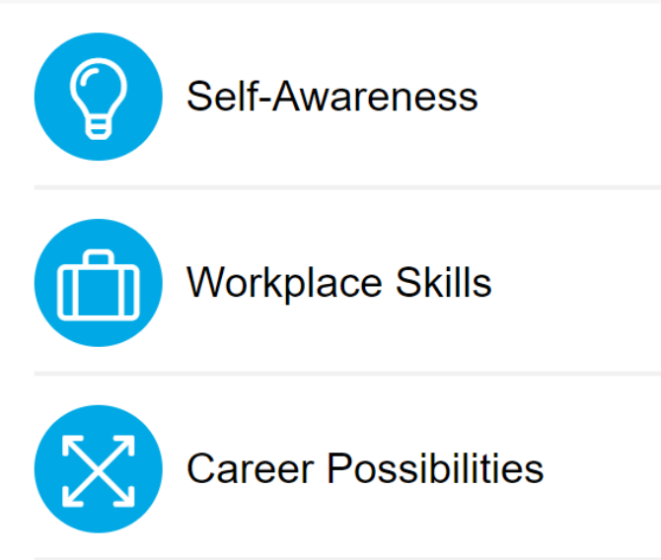

Goals: Start thinking about what you are learning through the Professional Development Program, what are your career goals now and what actions will you take to achieve them?
Remember, goals should be SMART (Specific, Measurable, Achievable, Realistic and Timely)
My career choice / job cluster

Potential employers?

Development needs/ skills required for future jobs
Current competencies / skills/ strengths
Employment experience

My current engagements/ extracurricular activities/volunteering

Education:
Who are you?

Values:

Interests:

Personality:

Skills:
My long-term career goals

My short-term career goals

My Action Plan (how and by when will you reach your goals?):
- How will I stand out from the crowd? Some ideas….
Homework

Continue to work through your MQ Career Ready Program, focussing on the following sections:

Notes

