Career & Employment Service

Table of Contents
These questions and clear steps are designed to bring you closer to your dream job and to develop your self-awareness and employability skills. The best way to use this workbook is to keep adding to it throughout the Professional Development Program, and beyond!
Professional Development Program
Workbook
1. My VIPS (Values, Interests, Personality, Skills)
2. Employability skills
3. Developing Experience
4. Informational Interview
5. Exploring your Options
6. My Career Goal
7. Job Search - Ways to look for work?
8. Job Analysis
9. My resume/CV
10. My referees
11. Cover letters
12. Be the recruiter exercise
13. Interview skills – Phone & Video Interviews
14. Interview skills – Guest presenter
15. Psychometric Testing & Gamification
16. Assessment Centres
17. Linkedin
18. Professional Branding
19. My Online Presence
20. Networking – My Elevator Pitch
21. Compass exercise questions
22. My Career Action Plan
23. How will I stand out from the crowd?

Session 4

- Assessment Centres

When thinking about assessment centres, which areas do you think you still need help with and need to improve on?

 | Why? | How/where could you practice? Who could help you?
Psych Testing

Group exercises

Presentations

Role Plays

Written Assessments

Interviews

Networking events

Other

Homework

Continue to work through your MQ Career Ready Program, focussing on the following sections:

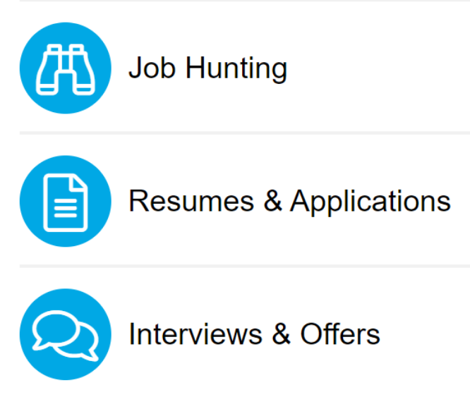

- Linkedin (Slide 54)

Homework

Build or review your Linkedin profile based on what you have learned today.

General Notes

